# Technical Documentation

# Introduction

This is that technical document for a data base that is airport:

The database has been made according to this scenario: In an airport there are employees that are trying to organize trips for the travellers, the booking of the trips can be done online be the travellers by choosing the trips, and the traveller can also register their bags online by giving information about them so they don’t have to do that in the airport.

In this technical document we are going in depth on the database, the security and validation and maintenance and many more.

# Physical Schema

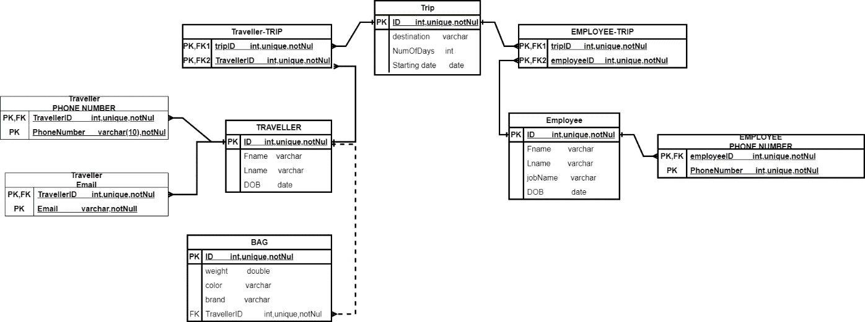

unique

unique

unique

# Database Development

## Database Overview

|  |  |  |
| --- | --- | --- |
| **Table** | **Name** | **Description** |
|  | trip | This table represent the information of the trip like (id, destination, trip starting date, number of days and trip name that is unique) |
|  | traveller | This table has the information of the travellers like their (id, first and last name, date of birth and nickname) |
|  | Traveller_trip | This is the table the connects the travellers to the trips that they booked, it has columns like(traveller id, trip id) |
|  | employee | This table has the information of the employees, info like(id, first and last name, date of birth, and job description) |
|  | Employee_trip | This is the table the connects the employees to the trips that work on by (operating it, managing it…), it has columns like (employee id, trip id) |
|  | Employee_phonenumber | This table is for the employees phone numbers and it has the employee id and his phone number |
|  | Traveller_phonenumber | This table is for the travellers phone numbers and it has the traveller id and his phone number |
|  | Traveller_email | This table is for the travellers emails and it has the traveller id and his email |
|  | bag | This table is about the travellers bags and info about them like (id, weight, colour, brand, and the traveller FK) |

|  |  |  |
| --- | --- | --- |
| **View** | **Name** | **Description** |
|  | Number of jobs | This view shows the deferent jobs and the number of employees that work in each job. |
|  | Bags_owners | This view show the first and last name of the traveller and the number of his bag |
|  | Employees phone numbers | This view show the first and last name of the employees and shows their phone numbers |
|  | Traveller and their trips | This view shows the travellers first and last name and their trips destination and the starting date |

|  |  |  |
| --- | --- | --- |
| **Procedure** | **Name** | **Description** |
|  | Add a bag | This can add a new bag into the bags table and the user can give it all the variables(weight, color, brand, fragile, travellerid) |
|  | What is the job | By giving it the first and last name of an employee it gives them and his job name |
|  | Employees working on a trip | When you call it and enter a trip id it gives you all the employees (first and last name) that are working in or on that trip |
|  | Add an emp phone | This can make user insert a new record in the (employee_phonenumber) table by entering the id and the number |

## Security

|  |  |  |  |
| --- | --- | --- | --- |
| **User name** | **Privilege Command** | **Description** | **Screenshot** |
| Ahmad identified by 123 | Select on a view called (bags_owners) | The user can now see the pre made view that is bags_owners |  |
| Select on a view called (Numberofjobs) | The user can now see the pre made view that is numberofjobs |  |
| Excute the procedure that is add_a_bag | The user can now add a bag by the procedure by entering the bag info |  |
|  | Granted the privilege to select insert update delete on the traveller table | The user can select and insert and update and delete from the traveller table |  |
| Granted the privilege to update (jobname) and select on the employee table | The user can now update the job name attribute for table employee  And select to the table |  |
|  | Given the ability to select and update on the table (traveller_phonenumber) to Ahmad | The user can now update the records on the table and see(select) what is in it |  |

## User Interface

### Flowchart and Data Movement Diagrams

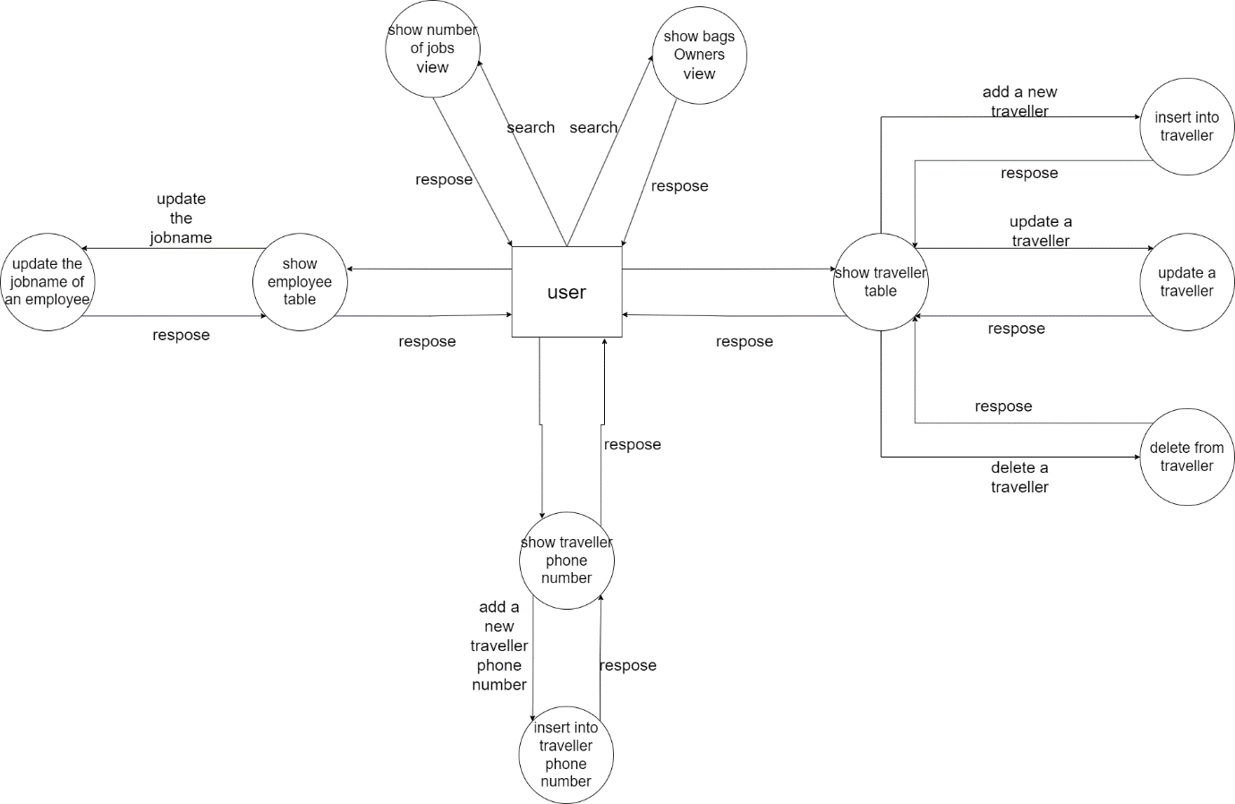

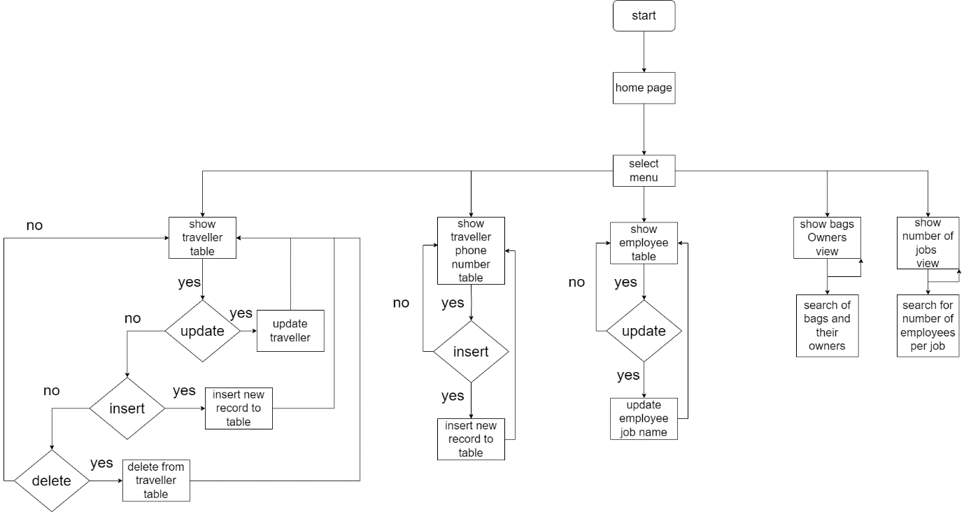

### Interfaces Development

|  |  |  |  |
| --- | --- | --- | --- |
| **Page ID** | **Title** | **Description** | **Screenshot** |
|  | Employee | In this page the user can (see) select the deferent records and he can only update on the jobname attribute |  |
|  | Traveller | In this page the user can select or update or insert or delete from the table traveller records |  |
|  | Traveller Phonenumber | In this page the user can select and update on the table traveller_phone number records |  |
|  | Bags Owners | In this page the user can select from the view that is (bags Owners) |  |
|  | Numberofjobs | In this page the user can select from the view that is (Numberofjobs) |  |

# Maintenance

## Database recovery & backups

Database backup:

A backup is a replica of your database made at a particular moment in time.  basically, it's a copy of your data that may be used to repair data loss or corruption and restore your database to its original state.

Types of backups:

Full Backup: The most reliable kind of backup, a full backup includes every piece of information in the database.

Differential Backup: Only the data that has changed since the last full backup is included in this form of backup. Both backup time and storage space needs are decreased.

Incremental Backup: Incremental backups only contain the information that has changed since the last backup, which could have been a full or incremental backup. The restoration techniques for these backups are the most complicated despite their modest size.

Establishing a backup schedule that works for your firm is essential. Backups on a daily, weekly, and monthly basis are typical schedules. Data recovery is guaranteed in the event of natural disasters like fires or floods by storing backups elsewhere or in the cloud.

Data recovery:

What is database recovery? After a data loss or corruption event, database recovery involves bringing the database back to its original, consistent, and usable state.

<https://www.tutorialspoint.com/Database-Backup-and-Recovery>

Steps for data recovery:

*Restore the most recent backup.

*Apply transaction logs (if using complete or bulk-logged recovery models) to bring the database up to the desired recovery point.

*Determine the cause of data loss or corruption.

*Check the restored database to make sure it is operational.

<https://www.tutorialride.com/dbms/database-recovery.htm>

## Database maintenance in general

The phrase "database maintenance" refers to a group of operations that are all carried out with the goal of enhancing your database. There are procedures designed to improve performance, clear up disk space, check for data mistakes, check for hardware problems, update internal statistics, and many more basic (but crucial) things.

*Four main "Categories" of processes make up database maintenance program:

1.Defragmenting the index:

2.Maintenance of Log Files

3.Data/File Compression

4.Integrity Review

The continuing process of database maintenance needs attention and resources. It makes ensuring that your database system is still reliable, secure, and able to efficiently meet your organization's data demands.

<https://www.officetools.com/knowledgebase/database-maintenance-explained/#:~:text=Database%20Maintenance%20is%20a%20term,obscure%20(but%20important)%20things>.

# Testing

## Data Validation

|  |  |  |  |
| --- | --- | --- | --- |
| **Number** | **Type** | **Description** | **screenshot** |
|  | All cases of PK | In the employee_trip table the PK is made out of two FKs one is the emoloyeeid and the other is the tripid but when they are combined they create the PK, and I tried to make a new record with an existing with the same PK |  |
| In employee table the id is the PK and there was a record with the id (5) already but I tried to make another one |  |
|  | All cases of FK | There is a table called traveller_email and it has the travellerid as a FK, so I tried to add a record but with an id that is not used (there is on id = 3 in the traveller table) |  |
| In the table bag there is a FK (traveller id ) that points to the PK in the traveller table so I tried to give the FK an id that is not used as a PK |  |
| In the table traveller_trip there is a FK (trip id ) that points to a PK in the trip table, so I tried to give the FK and id that is not used as PK |  |
| In the table employee_phonenumber the employeeid is a FK that points to the id in employee table so I gave the FK an id that is not used as a PK |  |
|  | Unique | In the table trip there is an attribute that is called (name) that is the name of the trip and I made it unique to no name is the same, and I tried to enter a name that is previously used |  |
|  | Default | In the table traveller gender is set to default to “M” so when I entered a new record with out specifying the gender it was set to “M” |  |
|  | Not null |  |  |
|  | Check | In the table bag I made a check constraint to make sure that the bag does is not more that 30 kg, and I tried to add a record that has 40 kg |  |
|  | ……… |  |  |

## Output Validation

|  |  |  |  |
| --- | --- | --- | --- |
| **Number** | **Query Description** | **Screenshot (query + result)** | **Result validation** |
|  | In this case we want to get the traveller (Fname, dob, gender) and to get their respective bags information like their (weight, and if they are fragile), also the bags weight has to be more than 10 and they are not fragile |  | The result gave me information about the traveller attributes like (fname, dob and gender)and the bag info like (the weight and fragile) as expected and it gave mo the records that has more weight than 10 and is not fragile |
|  | In this case I want to retrieve the traveller (Fname and Lname ) and their emails, and phone numbers (innerjoin) |  | The result gave me information about the traveller attributes like name and info like phone number and email, it showed the records for travellers that has records in all tables |
|  | In this case I want to retrieve the traveller name and that sum of the bags weight he has and I made it to be a left join so even if he dose no have bags get written, and orderd by sum from bigger to smaller |  | The result gave me the travellers name and the sum eight of their respective bags and because of left join the travellers that dose not have bags have null value under the sum of weight, and it is ordered by the sum of weight from bigger to smaller |
|  | In this case I wanted to get the trip destination and their sum of days in them and they have to be more than 9 days |  | The result is the deferent destinations and the sum of days in them (the number of days are grouped by the destination) and only for sum bigger than 9 days |

## Security Validation

**Note**: you need to test the given and not given privileges.

|  |  |  |  |
| --- | --- | --- | --- |
| **Number** | **User Name** | **Description of privilege/no privilege** | **Screenshot (query + result)** |
|  | Ahmad | Select on a view called (bags_owners) |  |
|  | Ahmad | Granted the prevlage to select insert update delete on the traveller table |  |
|  | Ahmad | Excute the procedure that is add_a_bag |  |
|  | Ahmad | Granted the privilege to update (jobname) on the employee table | Before update    After update |
|  | Ahmad | No privilege to insert into employee table |  |
|  |  | Privilege to update and select on (traveller_phonenumber) |  |
|  |  | Select on a view called (numberofjobs) |  |

### 

## GUI Validation

|  |  |  |
| --- | --- | --- |
| **Number** | **Description** | **screenshot** |
|  | Trying the select on bags Owners page |  |
|  | Trying the select on numberofjobs |  |
|  | Using the privileges that are given to the user on the traveller page that is select insert update delete |  |
|  | Using the update (of the jobname) on the page employee |  |
|  | Using the update on phone number on page traveller_phone number |  |

## Assess whether meaningful data has been extracted

All the tables and views and procedures gives meaning full data for the user, the user has to have privileges to the data that he wants to see, and I made the tables and view and procedures and the privileges he has on them will give the user a relevant and meaningful data that can be used and be helpful if it is going to be used in a real life application and here are some examples:

1. The user have a privilege to select from a view called (numberofjobs) that displays the deferant jobs and how many employees work on those jobs and that can be very helpful if the user is a manager.
2. The user can add and select(see) the records from the table (traveller_phonenumber) and the cam be helpful and meaning full if the user is a receptionist and want to add or call a traveller.
3. The user can use the (bags owners) view that is in the GUI and can easily recognize the which bag belongs to which traveller and that is helpful and meaning full if they want to locate the travellers bags.
4. The user can see and and update the jobname of the employees if they changed their work or had a promotion and that can be helpful to keep check of every ones position and responsibility.

## Assess the effectiveness of testing

Testing helps in finalizing the database and that the database is working as expected to make sure that the data gets inserted correctly and the tables have the right relation between them, and the users to check if they have the right privileges that are given to them to insure that the data base can be useable and secured from and for the users.

Testing can help you identify mistakes to be able to fix them before finalizing and using the database so it works as expected.

# Evaluation of database solution

## Effectiveness of the database solution based on user and system requirement

## Suggested improvements

## Evaluation based on improvements needed